

**MULTIMEDIA APPLICATION**

**Environment and Pollution**

Name : NG HO KIT

Student I.D. : TP035012

Intake Code : UCDF1405ICT(SE)

Course Code : AINT001-4-2-MMA

Lecturer Name : Mr. Rabinath Kulasegaram

Due Date : 23rd November 2015

# Table of Content

Table of Content 1

Acknowledgement 2

Objective 3

Targeted users’ Background 4

Targeted system requirement 5

Concepts Arts and character design 6

Abstract 9

Application Structure 10

Storyboard 11

Creative and Unique features 14

References 20

# Acknowledgement

First of all, I would like to offer my sincere thanks to Mr. Rabinath Kulasegaram, the lecturer for assisting and guiding me until I complete this project. Also, a special thanks to my parent who assisting and provide support for me during the completion of this project.

Besides that, I also would like to offer my salutation to Loh Yeani, Navinder and Izzat for giving me ideas, advices and suggestions when I lack of something in my project.

Last but not least, special thanks to all fellow classmates for willing to help me when I’m having difficulties during the completion of the project.

# Objective

Objective of this project:

* To raise public awareness about the environment.
* To tell the public about the impact of pollution.
* To show the public the importance of keeping the environment clean.
* To guide the public how to keep the environment clean.
* To reduce the current pollution problem.

# Targeted users’ Background

**Background**

This animation is aimed for students, adults and also children from age of 12 years old to 60 years old. The audiences expected should be from different family or environment background. Because most pollution are man-made, so this animation is most probably targeted audience with bad habit that lead to pollution. This animation is also aimed to raise the awareness of public which currently having serious pollution problem.

# Targeted SYSTEM REQUIREMENT

|  |  |  |
| --- | --- | --- |
|  | **Minimum Requirements** | **Recommended Specification** |
| Operating System | Windows XP | Windows 7 and above |
| Processor | Intel® Core™ Duo E6600 | Intel® Core™ i5 |
| Video | NVIDIA® GeForce® 8800GT | NVIDIA® GeForce 820M |
| Memory | 1GB of RAM | 2GB of RAM |
| Storage | 1GB available hard drive space | 2GB available hard drive space |

# Concepts Arts and character design

The main character of this project is the Earth itself, I’m implementing minimalist design for overall design. The concept of the earth is referring to online sources, and I modified it based on my needs.

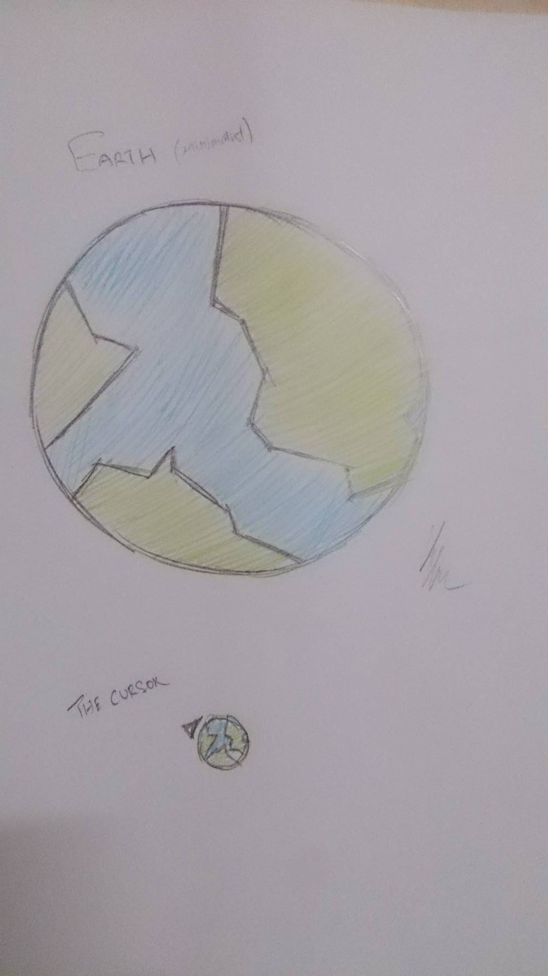

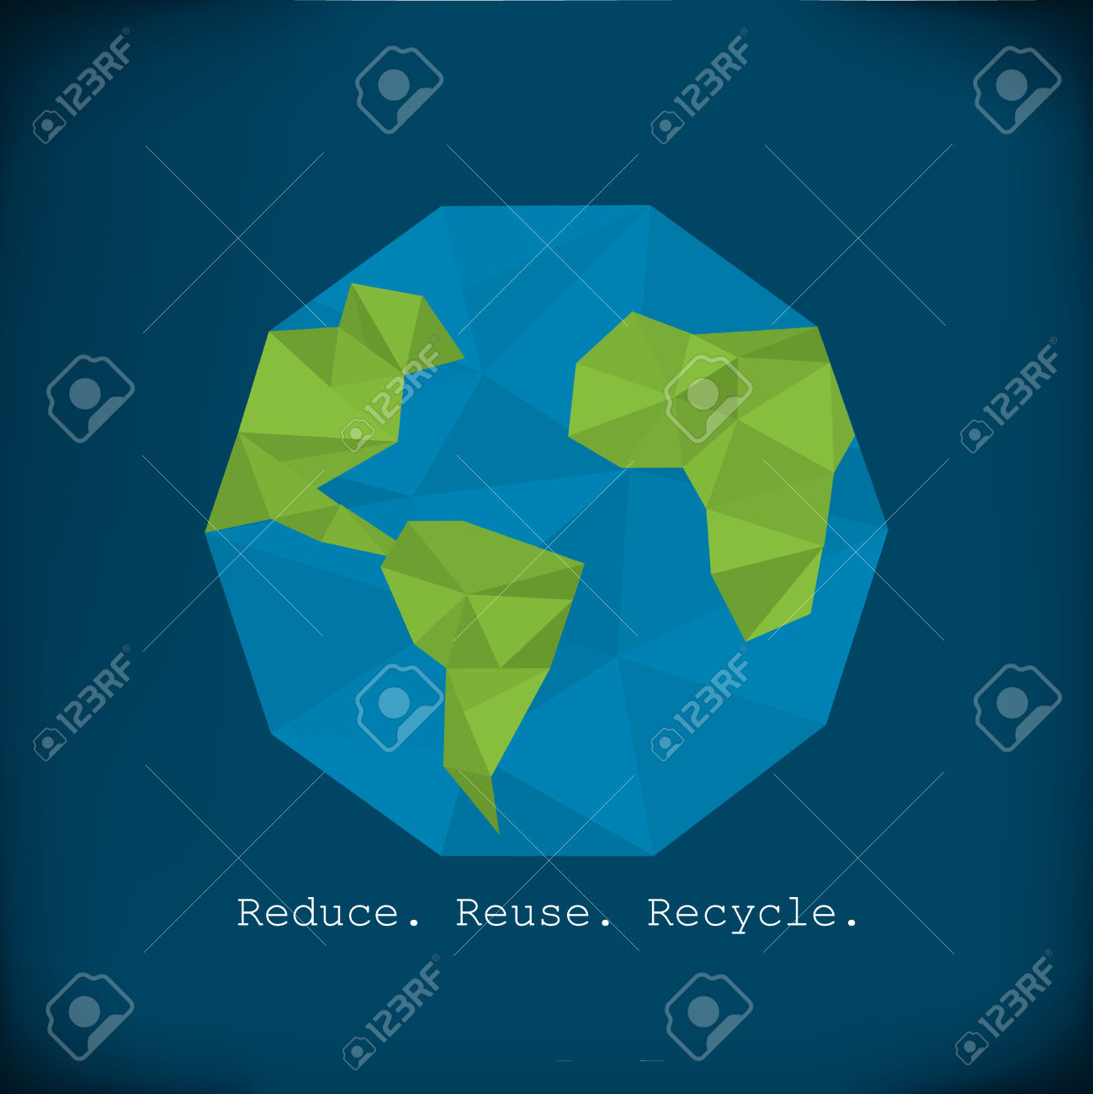

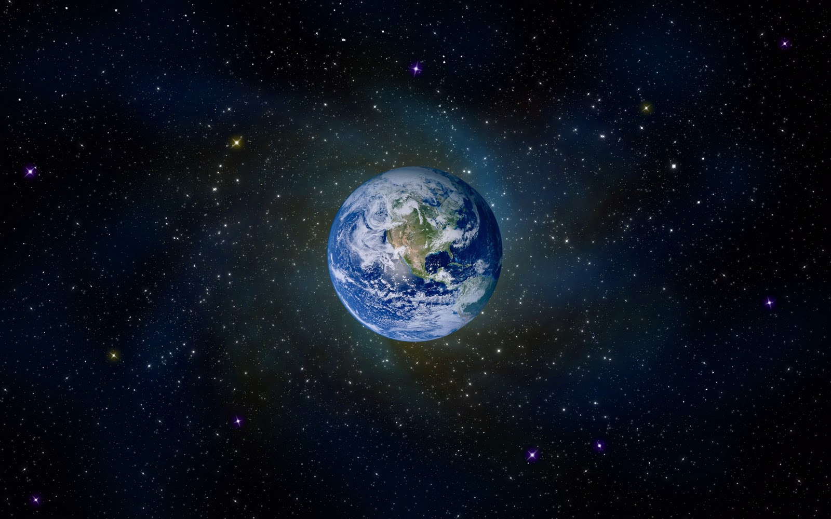

# Abstract

Nowadays, pollution around the globe becoming worse year by year, and these pollution has causes a lot of trouble to mankind. The main objective of this project is to raise public awareness of the current pollution problem and the way to prevent it. This project is to guide the public on how to keep the environment clean and reduce the current pollution problem.

With the topic I had chosen, I will be implementing minimalist design for my project based on my target audiences which age from 12 until 60 years old, students, adults and also children. The reason I choosing minimalist design is because nowadays a lot of company implementing minimalist design on their projects, websites and also their arts. So minimalist design is very common in the recent day and it should be suitable for my targeted audience.

When the user open the project, the project will full screen automatically, and the user are required to press the “Click here to start” button to proceed to main page, before proceed to main page, there will be a pre-loader that load the project. After loading, a video will be played, choose can choose to skip the video by pressing any random button. If user need help with the project, user can press on “Menu” button and click the button at the bottom right of the screen.

In the main menu, there will be multiple option of item inside the menu that allow user to navigate. For each pollution scene that user choose has its own video clip, when user selected a pollution scene, there will be a tiny “O” button that will navigate the user to the video. User also can press “Contact” button to know how to contact us. Besides, there will be a gallery that allow user to view pictures.

The benefit of doing this project is to tell the public the importance of keeping the environment clean and healthy.

# Application Structure



From landing page until main page, linear structure has been implemented, from menu page, hierarchical has been implemented which allow user to navigate to the page that user want. Each pages, linear structure has been implemented.

# Storyboard

**Scene 1:** Landing page



**Scene 2:** Loading page



**Scene 3:** Menu page



**Scene 4:** Content page



**Scene 4:** Help page



# Creative and Unique features

1. Background music

Background music has been added in the landing page.

1. Custom cursor

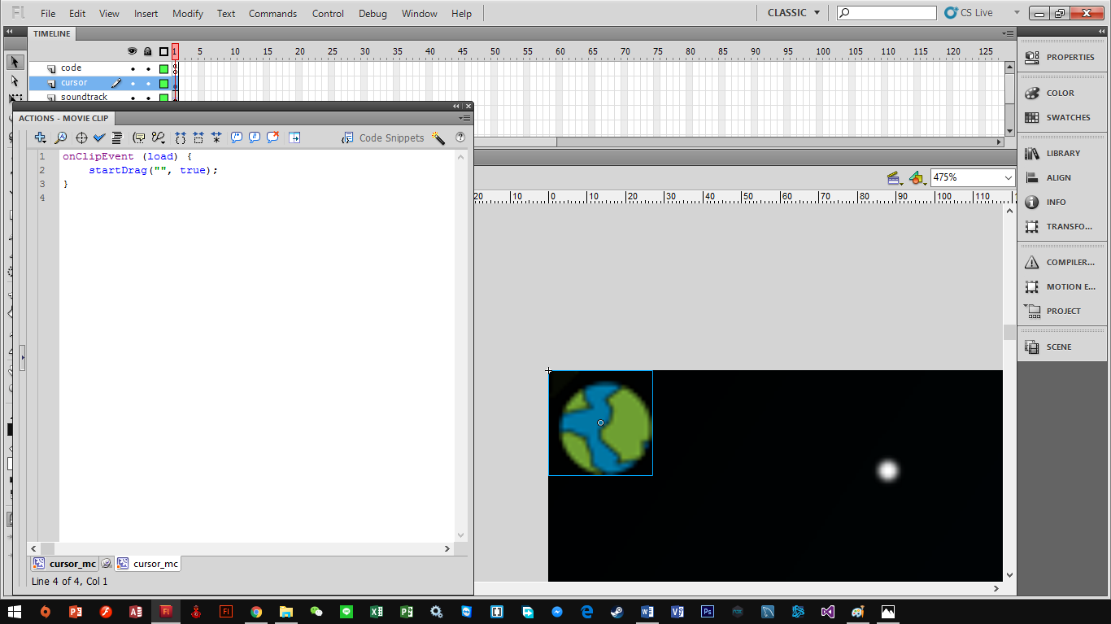

Custom cursor has been added into the project, when the audience move the mouse, the custom cursor will move along. In the code snippet shown in figure above, when the cursor (movie clip) appeared in the timeline, the cursor will move along with the movement of the mouse. In order to hide the system default’s cursor, Mouse.hide() has to be declared.

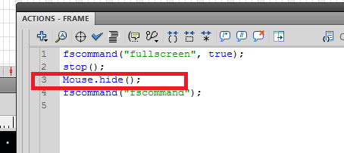

1. Loading feature

In the loading scene, preloader has been added to indicate the percentage of content currently loaded.

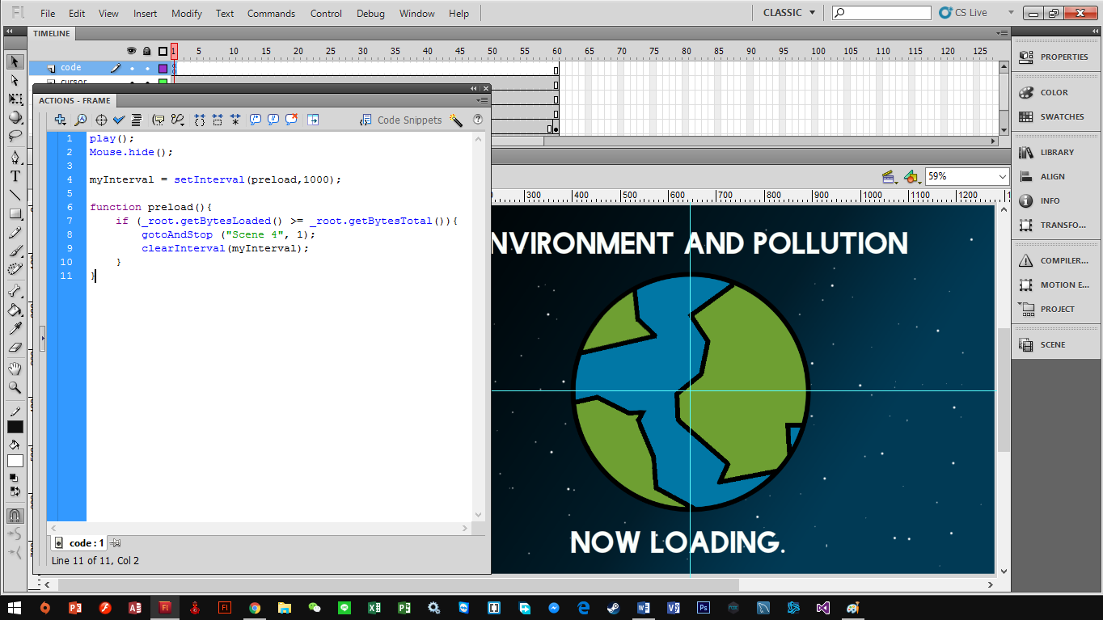

In the code snippet above, ActionScript 2.0 has been implemented.

myInterval: This act as a timer, it will run the preload function every 1000 millisecond (1second).

preload(): This function will calculate the data that will be loaded. After the project finish loaded, it will redirect the user to the Scene 4 (Content Page) and stop the timer (myInterval).

1. Help

In this project, “HELP” button has been applied into the project, after the user clicked the button, it will lead the user to “How to” page. Help button is available on landing page and also menu page.

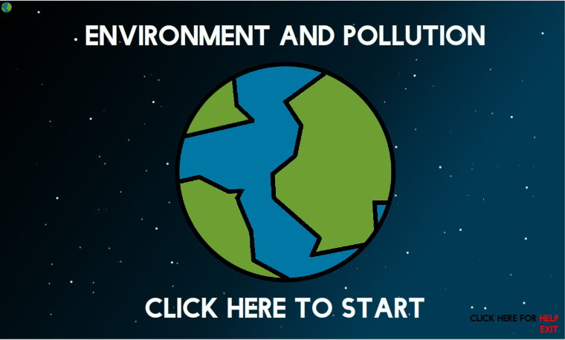

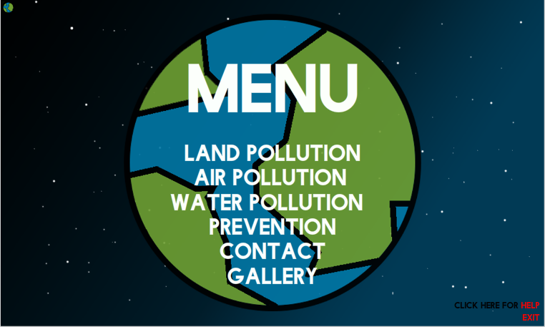

1. Gallery

Gallery has been added to allow user to view picture.

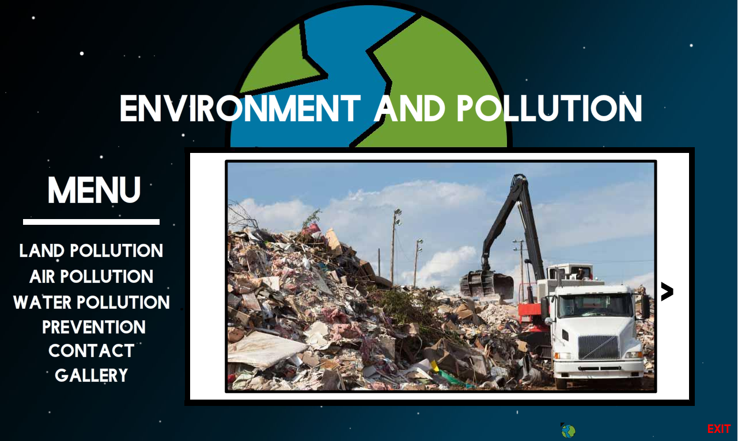

User can select either next or previous, when user click next (“>”) button, it will show the next picture, when user click on previous (“<”) button, it will display back the previous picture

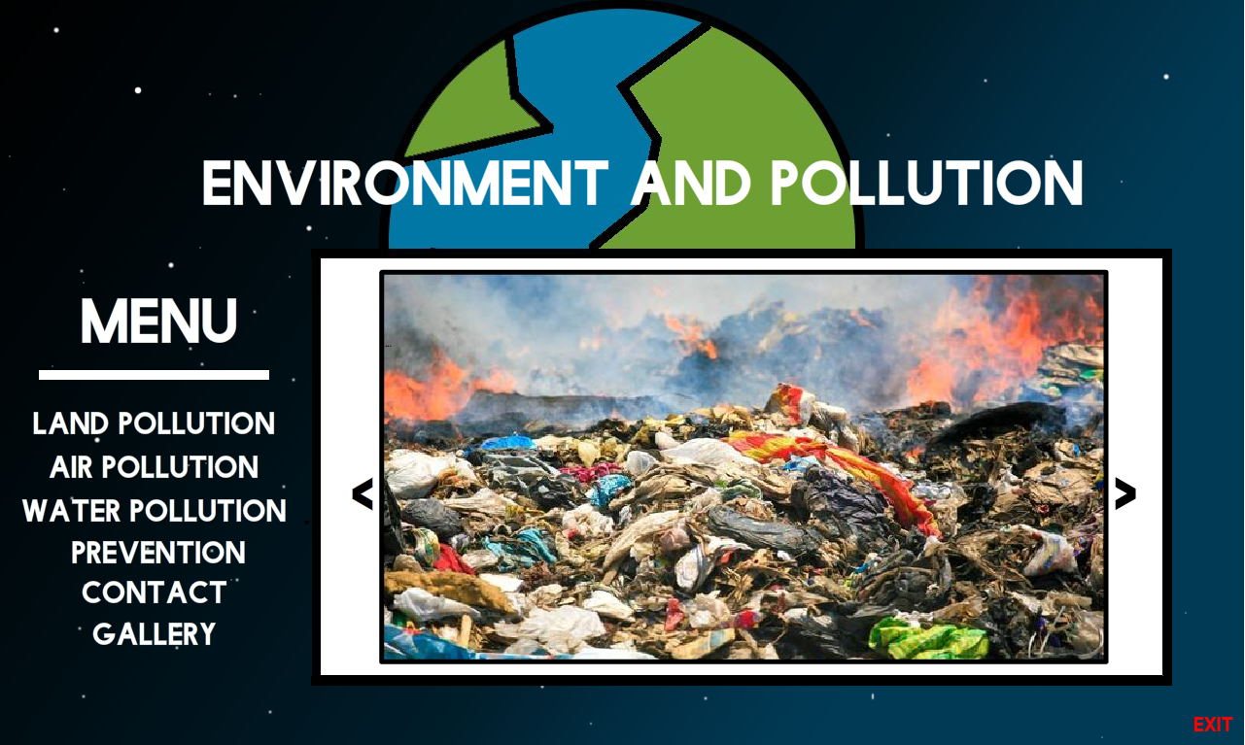.

1. Social Media

In the figure below, 3 major social media icon (facebook, twitter, and also YouTube) has been added, when the user press on these icon, it will redirect the user to the respective social media.

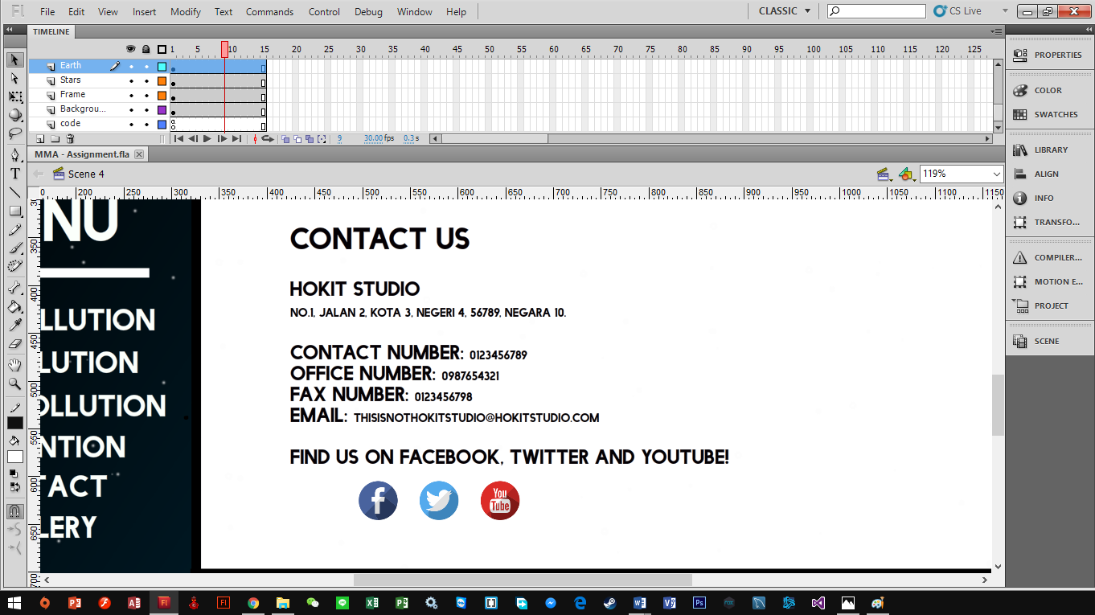

The ActionScript snippet used is as shown as below.

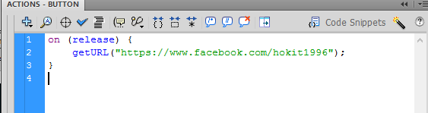

1. Video

Video has been added into the main page, and each pollution page. For each pollution page, user are required to press the “O” button to view the video. Example:

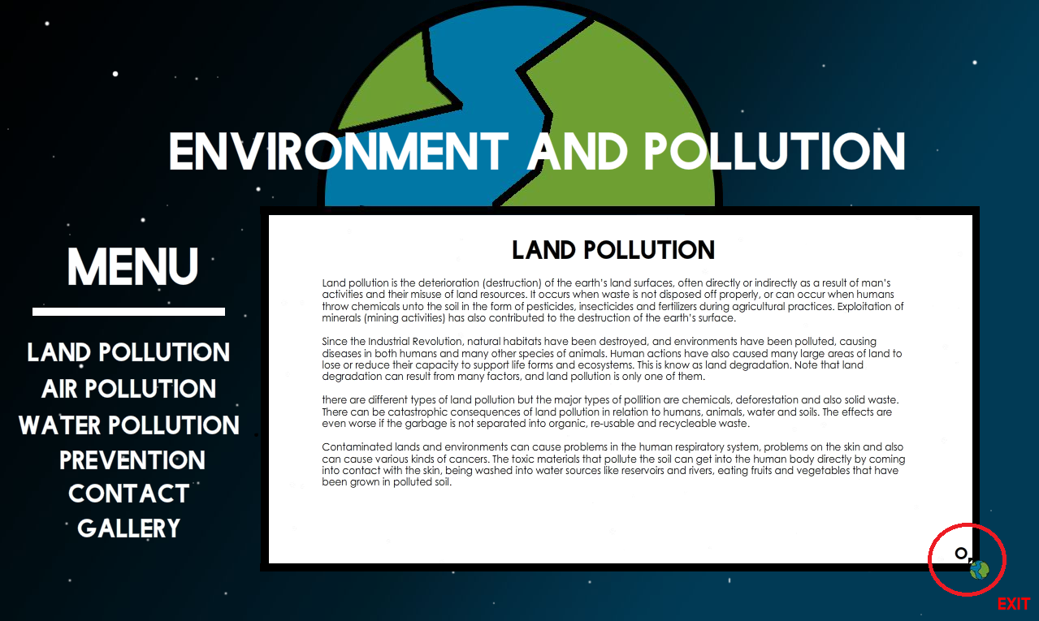

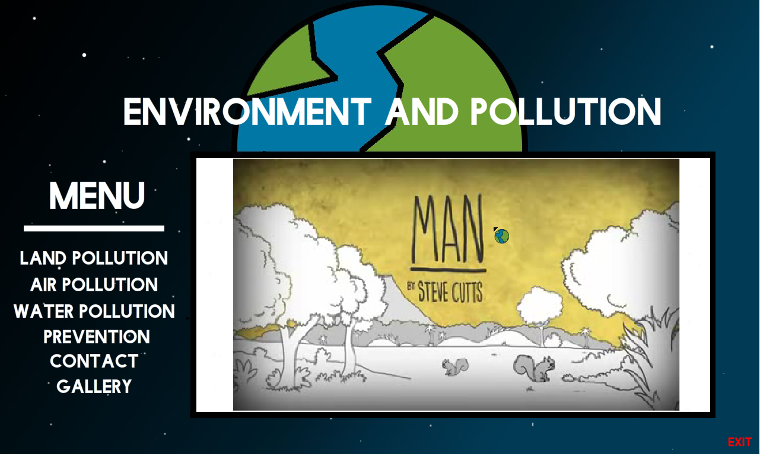

# References

Adobe, 2015. *Flash CS4 Professional ActionScript 2.0.* [Online]   
Available at: http://help.adobe.com/en_US/AS2LCR/Flash_10.0/help.html?content=00000587.html  
[Accessed 22 November 2015].

Blue_Chi, 2004 - 2010. *Republic of Code.* [Online]   
Available at: http://www.republicofcode.com/tutorials/flash/cursor_bc/  
[Accessed 22 November 2015].

McCauley, T., 2009. *senocular.com.* [Online]   
Available at: http://www.senocular.com/flash/tutorials/preloading/  
[Accessed 22 November 2015].